How Tires Work  by Karim Nice  ››Tell a friend about this article! |  | › Introduction to How Tires Work  › How Tires are Made  › What All the Numbers Mean  › Traction  › How Tires Support a Car  › Problems With Tires  › Lots More Information!  › Search Google  › Shop or Compare Prices  › What do you think?
If you're in the market for new tires, all of the variables in tire specifications and the confusing jargon you might hear from tire salesmen or "experts" might make your purchase rather stressful. Or maybe you just want to fully understand the tires you already have, the concepts at work, the significance of all of those sidewall markings. What does all this stuff mean in regular terms?
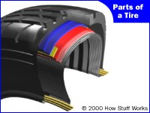
Cutaway view of a tire
In this edition of HowStuffWorks, we will explore how tires are built and see what's in a tire. We'll find out what all the numbers and markings on the sidewall of a tire mean, and we'll decipher some of that tire jargon. By the end of this article, you'll understand how a tire supports your car, and you'll know why heat can build up in your tires, especially if the pressure is low. You'll also be able to adjust your tire pressure correctly and diagnose some common tire problems!

How Tires are Made
As illustrated below, a tire is made up of several different components.
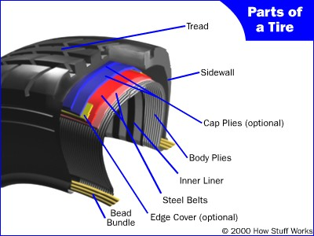
The parts of a tire
The Bead Bundle
The bead is a loop of high-strength steel cable coated with rubber. It gives the tire the strength it needs to stay seated on the wheel rim and to handle the forces applied by tire mounting machines when the tires are installed on rims.
The Body
The body is made up of several layers of different fabrics, called plies. The most common ply fabric is polyester cord. The cords in a radial tire run perpendicular to the tread. Some older tires used diagonal bias tires, tires in which the fabric ran at an angle to the tread. The plies are coated with rubber to help them bond with the other components and to seal in the air.
A tire's strength is often described by the number of plies it has. Most car tires have two body plies. By comparison, large commercial jetliners often have tires with 30 or more plies.
The Belts
In steel-belted radial tires, belts made from steel are used to reinforce the area under the tread. These belts provide puncture resistance and help the tire stay flat so that it makes the best contact with the road.
Cap Plies
Some tires have cap plies, an extra layer or two of polyester fabric to help hold everything in place. These cap plies are not found on all tires; they are mostly used on tires with higher speed ratings to help all the components stay in place at high speeds.
The Sidewall
The sidewall provides lateral stability for the tire, protects the body plies and helps keep the air from escaping. It may contain additional components to help increase the lateral stability.
The Tread
The tread is made from a mixture of many different kinds of natural and synthetic rubbers. The tread and the sidewalls are extruded and cut to length. The tread is just smooth rubber at this point; it does not have the tread patterns that give the tire traction.
Assembly
All of these components are assembled in the tire-building machine. This machine ensures that all of the components are in the correct location and then forms the tire into a shape and size fairly close to its finished dimensions.
Figura da Montagem
At this point the tire has all of its pieces, but it's not held together very tightly, and it doesn't have any markings or tread patterns. This is called a green tire. The next step is to run the tire into a curing machine, which functions something like a waffle iron, molding in all of the markings and traction patterns. The heat also bonds all of the tire's components together. This is called vulcanizing. After a few finishing and inspection procedures, the tire is finished.

What All the Numbers Mean
Each section of small print on a tire's sidewall means something:

Tire Type
The P designates that the tire is a passenger vehicle tire. Some other designations are LT for light truck, and T for temporary, or spare tires.
Tire Width
The 235 is the width of the tire in millimeters (mm), measured from sidewall to sidewall. Since this measure is affected by the width of the rim, the measurement is for the tire when it is on its intended rim size.
Aspect Ratio
This number tells you the height of the tire, from the bead to the top of the tread. This is described as a percentage of the tire width. In our example, the aspect ratio is 75, so the tire's height is 75 percent of its width, or 176.25 mm ( .75 x 235 = 176.25 mm, or 6.94 in). The smaller the aspect ratio, the wider the tire in relation to its height.

High performance tires usually have a lower aspect ratio than other tires. This is because tires with a lower aspect ratio provide better lateral stability. When a car goes around a turn lateral forces are generated and the tire must resist these forces. Tires with a lower profile have shorter, stiffer sidewalls so they resist cornering forces better.
Tire Construction
The R designates that the tire was made using radial construction. This is the most common type of tire construction. Older tires were made using diagonal bias (D) or bias belted (B) construction. A separate note indicates how many plies make up the sidewall of the tire and the tread.
Rim Diameter
This number specifies, in inches, the wheel rim diameter the tire is designed for.
Uniform Tire Quality Grading
Passenger car tires also have a grade on them as part of the uniform tire quality grading (UTQG) system. You can check the UTQG rating for your tires on this page maintained by the U.S. National Highway Traffic Safety Administration (NHTSA). Your tire's UTQG rating tells you three things:
- Tread Wear: This number comes from testing the tire in controlled conditions on a government test track. The higher the number, the longer you can expect the tread to last. Since no one will drive his or her car on exactly the same surfaces and at the same speeds as the government test track, the number is not an accurate indicator of how long your tread will actually last. It's a good relative measure, however: You can expect a tire with a larger number to last longer than one with a smaller number.
- Traction: Tire traction is rated AA, A, B or C, with AA at the top of the scale. This rating is based on the tire's ability to stop a car on wet concrete and asphalt. It does not indicate the tire's cornering ability. According to this NHTSA page, the Firestone Wilderness AT and Radial ATX II tires that have been in the news have a traction rating of B.
- Temperature: The tire temperature ratings are A, B or C. The rating is a measure of how well the tire dissipates heat and how well it handles the buildup of heat. The temperature grade applies to a properly inflated tire that is not overloaded. Underinflation, overloading or excessive speed can lead to more heat buildup. Excessive heat buildup can cause tires to wear out faster, or could even lead to tire failure. According to this NHTSA page, the Firestone Wilderness AT and Radial ATX II tires have a temperature rating of C.
Service Description
The service description consists of two things:
- Load Ratings: The load rating is a number that correlates to the maximum rated load for that tire. A higher number indicates that the tire has a higher load capacity. The rating "105," for example, corresponds to a load capacity of 2039 pounds (924.87 kg). See the chart on this page for all the ratings. A separate note on the tire indicates the load rating at a given inflation pressure.
- Speed Rating: The letter that follows the load rating indicates the maximum speed allowable for this tire (as long as the weight is at or below the rated load). For instance, S indicates that the tire can handle speeds up to 112 mph (180.246 kph). See the chart on this page for all the ratings.
Calculating the Tire Diameter
Now that we know what these numbers mean, we can calculate the overall diameter of a tire. We multiply the tire width by the aspect ratio to get the height of the tire.
Tire height = 235 x 75 percent = 176.25 mm (6.94 in)
Then we add twice the tire height to the rim diameter.
2 x 6.94 in + 15 inches = 28.9 in (733.8 mm)
This is the unloaded diameter; as soon as any weight is put on the tire, the diameter will decrease.

Traction
There are a lot of different terms used today in the tire industry. Some of them actually mean something and some do not. In this section, we'll try to explain what some of the terms mean.
All-Season Tires with Mud and Snow Designation
If a tire has MS, M+S, M/S or M&S on it, then it meets the Rubber Manufacturers Association (RMA) guidelines for a mud and snow tire. For a tire to receive the Mud and Snow designation, it must meet these geometric requirements (taken from the bulletin "RMA Snow Tire Definitions for Passenger and Light Truck (LT) Tires"):
1. New tire treads shall have multiple pockets or slots in at least one tread edge that meet the following dimensional requirements based on mold dimensions:
a. Extend toward the tread center at least 1/2 inch from the footprint edge, measured perpendicularly to the tread centerline.
b. A minimum cross-sectional width of 1/16 inch.
c. Edges of pockets or slots at angles between 35 and 90 degrees from the direction of travel.
2. The new tire tread contact surface void area will be a minimum of 25 percent based on mold dimensions.
The rough translation of this specification is that the tire must have a row of fairly big grooves that start at the edge of the tread and extend toward the center of the tire. Also, at least 25 percent of the surface area must be grooves.
The idea is to give the tread pattern enough void space so that it can bite through the snow and get traction. However, as you can see from the specification, there is no testing involved.
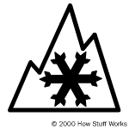
Severe winter traction icon
To address this shortcoming, the Rubber Manufacturers Association and the tire industry have agreed on a standard that does involve testing. The designation is called Severe Snow Use and has a specific icon (see image at right), which goes next to the M/S designation.
In order to meet this standard, tires must be tested using an American Society for Testing and Materials (ASTM) testing procedure described in "RMA Definition for Passenger and Light Truck Tires for use in Severe Snow Conditions":
Tires designed for use in severe snow conditions are recognized by manufacturers to attain a traction index equal to or greater than 110 compared to the ASTM E-1136 Standard Reference Test Tire when using the ASTM F-1805 snow traction test with equivalent percentage loads.
These tires, in addition to meeting the geometrical requirements for an M/S designation, are tested on snow using a standardized test procedure.They have to do better than the standard reference tire in order to meet the requirements for Severe Snow Use.
Hydroplaning
Hydroplaning can occur when the car drives through puddles of standing water. If the water cannot squirt out from under the tire quickly enough, the tire will lift off the ground and be supported by only the water. Because the affected tire will have almost no traction, cars can easily go out of control when hydroplaning.
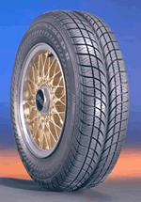
Photo courtesy Goodyear
A tire designed to help prevent hydroplaning
Some tires are designed to help reduce the possibility of hydroplaning. These tires have deep grooves running in the same direction as the tread, giving the water an extra channel to escape from under the tire.

How Tires Support a Car
You may have wondered how a car tire with 30 pounds per square inch (psi) of pressure can support a car. This is an interesting question, and it is related to several other issues, such as how much force it takes to push a tire down the road and why tires get hot when you drive (and how this can lead to problems).
The next time you get in your car, take a close look at the tires. You will notice that they are not really round. There is a flat spot on the bottom where the tire meets the road. This flat spot is called the contact patch, as illustrated below.

If you were looking up at a car through a glass road, you could measure the size of the contact patch. You could also make a pretty good estimate of the weight of your car, if you measured the area of the contact patches of each tire, added them together and then multiplied the sum by the tire pressure.
Since there is a certain amount of pressure per square inch in the tire, say 30 psi, then you need quite a few square inches of contact patch to carry the weight of the car. If you add more weight or decrease the pressure, then you need even more square inches of contact patch, so the flat spot gets bigger.
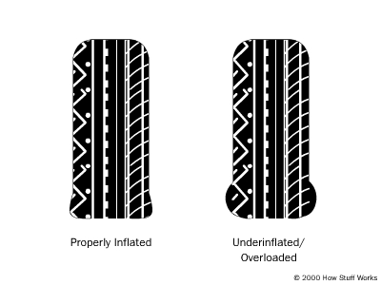
A properly inflated tire and an underinflated or overloaded tire
You can see that the underinflated/overloaded tire is less round than the properly inflated, properly loaded tire. When the tire is spinning, the contact patch must move around the tire to stay in contact with the road. At the spot where the tire meets the road, the rubber is bent out. It takes force to bend that tire, and the more it has to bend, the more force it takes. The tire is not perfectly elastic, so when it returns to its original shape, it does not return all of the force that it took to bend it. Some of that force is converted to heat in the tire by the friction and work of bending all of the rubber and steel in the tire. Since an underinflated or overloaded tire needs to bend more, it takes more force to push it down the road, so it generates more heat.
Tire manufacturers sometimes publish a coefficient of rolling friction (CRF) for their tires. You can use this number to calculate how much force it takes to push a tire down the road. The CRF has nothing to do with how much traction the tire has; it is used to calculate the amount of drag or rolling resistance caused by the tires. The CRF is just like any other coefficient of friction: The force required to overcome the friction is equal to the CRF multiplied by the weight on the tire. This table lists typical CRFs for several different types of wheels.
Tire Type | Coefficient of Rolling Friction
Low rolling resistance car tire | 0.006 - 0.01
Ordinary car tire | 0.015
Truck tire | 0.006 - 0.01
Train wheel | 0.001
Let's figure out how much force a typical car might use to push its tires down the road. Let's say our car weighs 4,000 pounds (1814.369 kg), and the tires have a CRF of 0.015. The force is equal to 4,000 x 0.015, which equals 60 pounds (27.215 kg). Now let's figure out how much power that is. If you've read the HowStuffWorks article How Force, Torque, Power and Energy Work, you know that power is equal to force times speed. So the amount of power used by the tires depends on how fast the car is going. At 75 mph (120.7 kph), the tires are using 12 horsepower, and at 55 mph (88.513 kph) they use 8.8 horsepower. All of that power is turning into heat. Most of it goes into the tires, but some of it goes into the road (the road actually bends a little when the car drives over it).
From these calculations you can see that the three things that affect how much force it takes to push the tire down the road (and therefore how much heat builds up in the tires) are the weight on the tires, the speed you drive and the CRF (which increases if pressure is decreased).
If you drive on softer surfaces, such as sand, more of the heat goes into the ground, and less goes into the tires, but the CRF goes way up.

Problems With Tires
Underinflation can cause tires to wear more on the outside than the inside. It also causes reduced fuel efficiency and increased heat buildup in the tires. It is important to check the tire pressure with a gauge at least once a month.
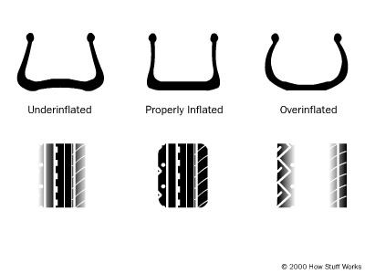
The wear patterns of an underinflated, properly inflated and overinflated tire
Overinflation causes tires to wear more in the center of the tread. The tire pressure should never exceed the maximum that is listed on the side of the tire. Car manufacturers often suggest a lower pressure than the maximum because the tires will give a softer ride. But running the tires at a higher pressure will improve mileage.
Misalignment of the wheels causes either the inside or the outside to wear unevenly, or to have a rough, slightly torn appearance.
For more information on tires and related topics, check out the links on the next page.

